|  |  |
| --- | --- |
| **Lab 4: Using Metasploit with Command Execution** | |
| **Name** | Tran Minh Triet |
| **Student ID** | SE172241 |

**Start Up Damn Vulnerable Web App (DVWA)**

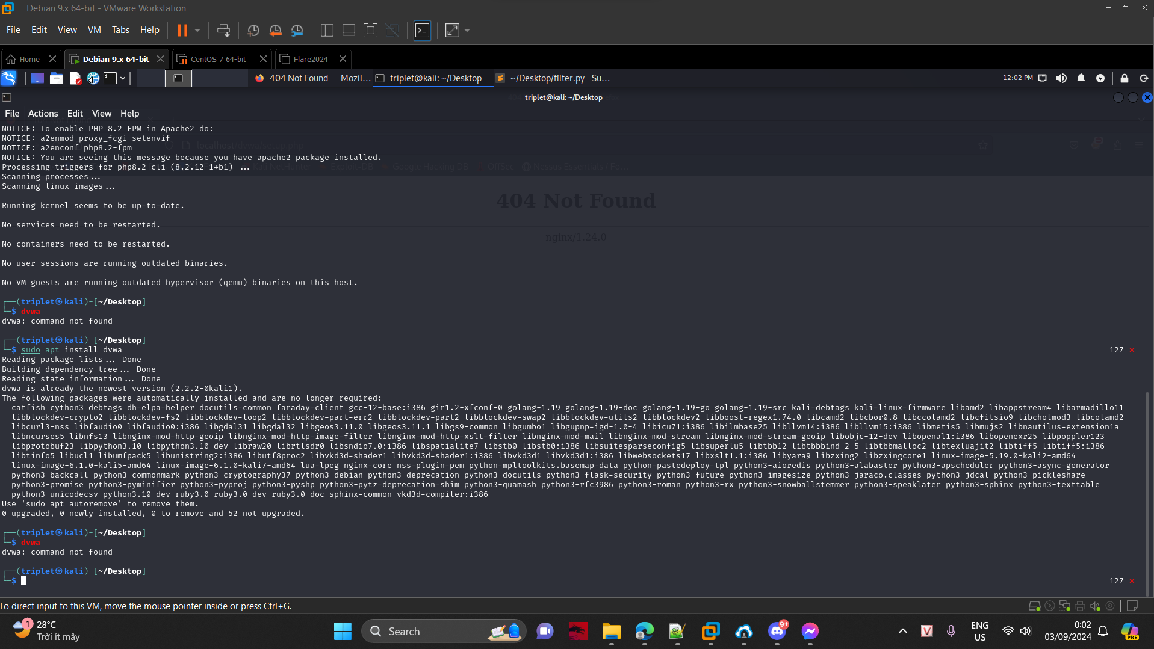

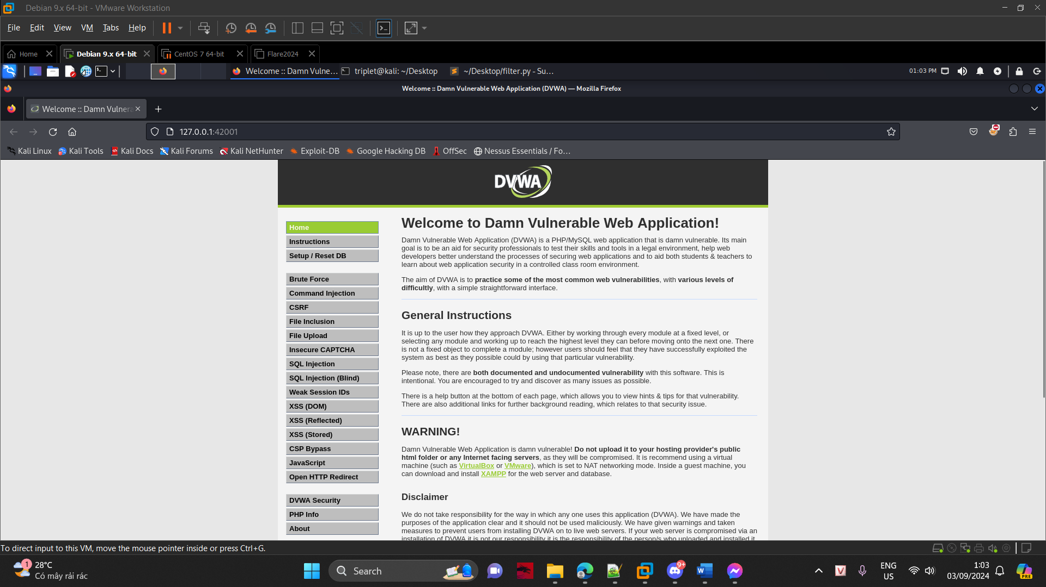

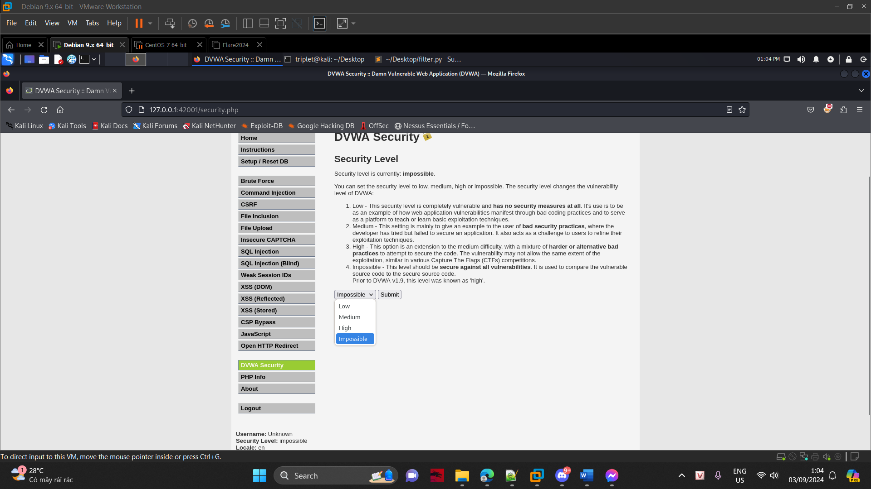

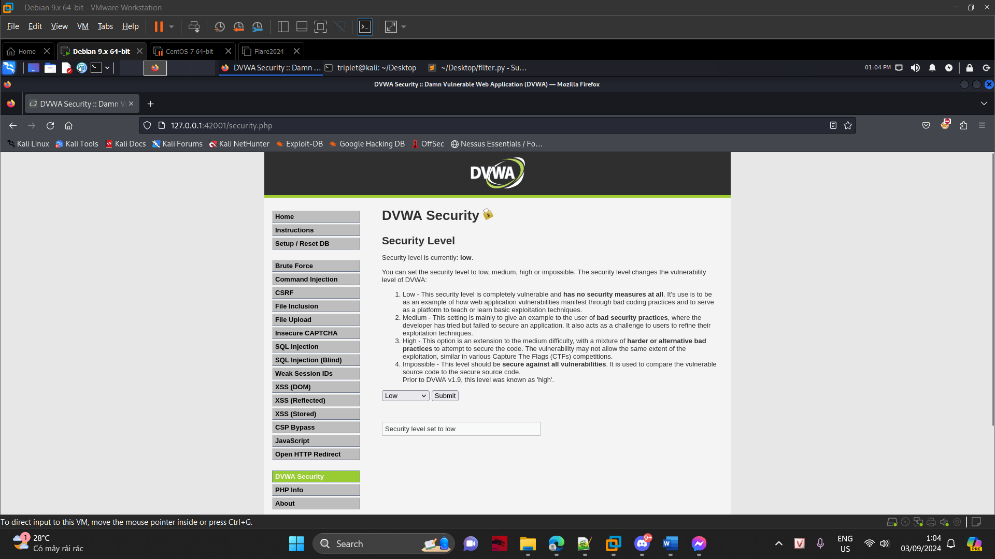

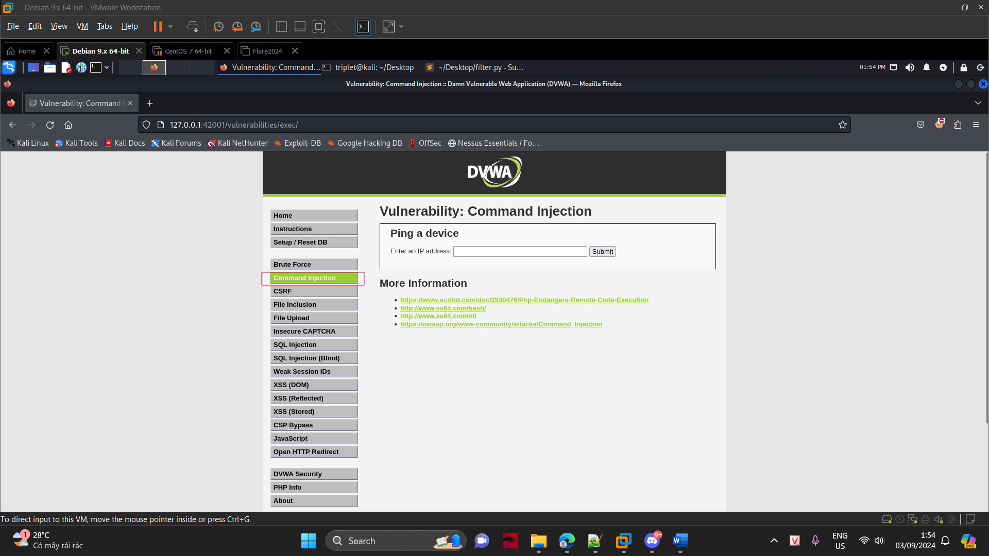

**Command Execution**

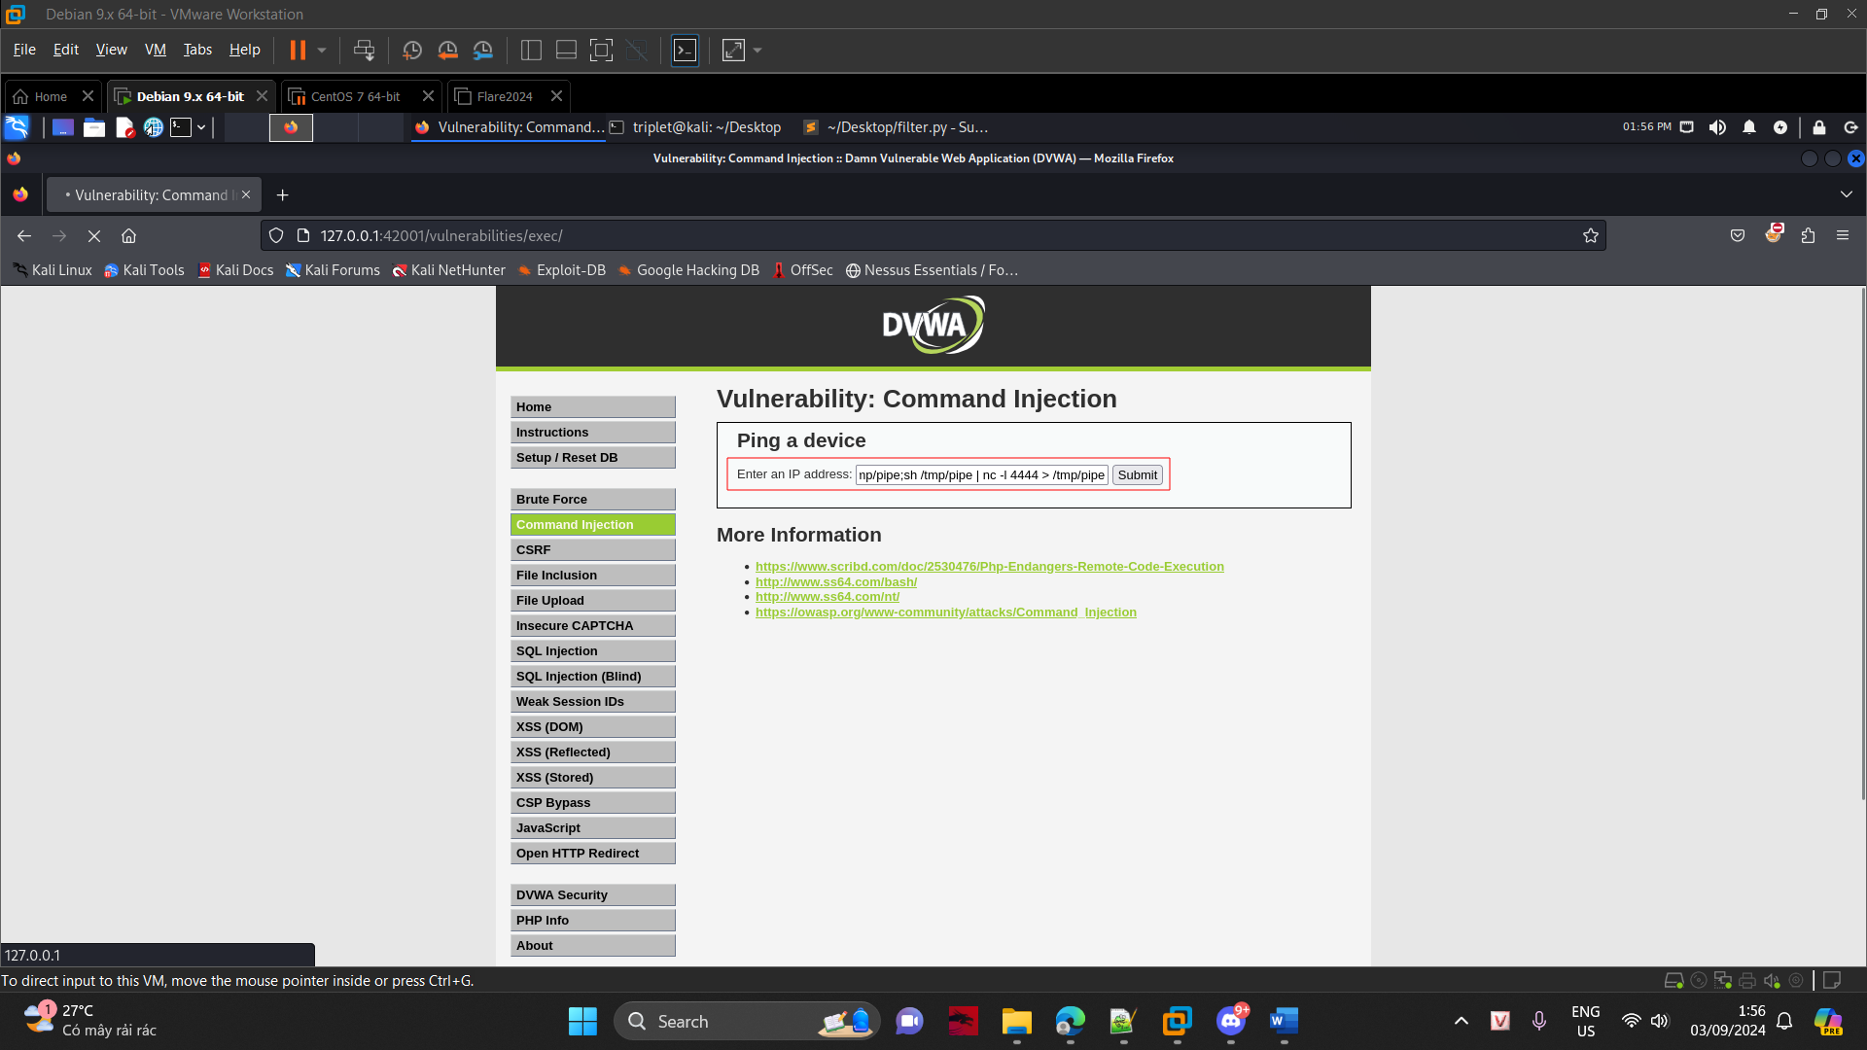

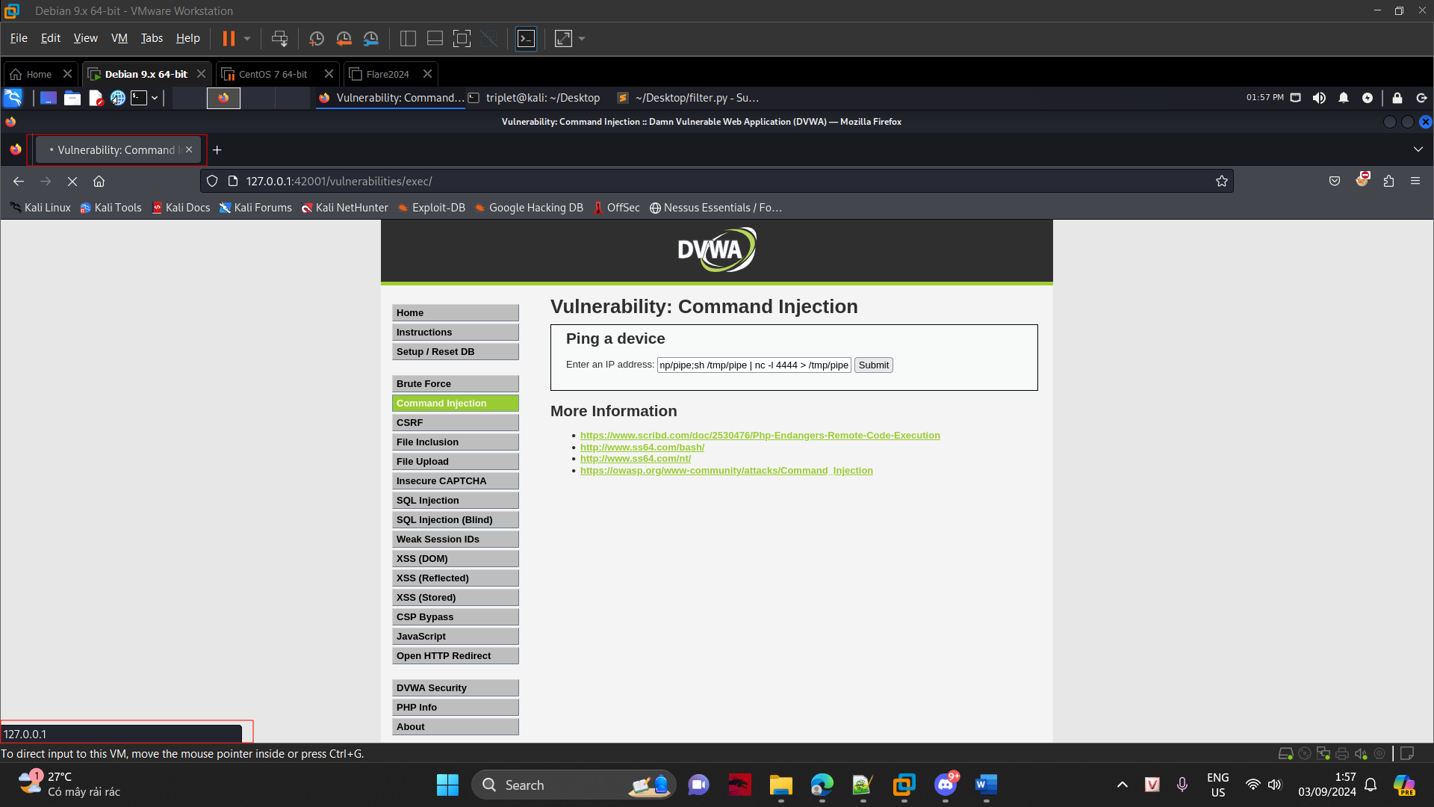

**Use Metasploit to Connect to DVWA's Netcat session**

